SriLanka InstituteofInformation Technology
Data warehousing and Business Intelligence
Assignment 1



KUMARAGE C D – IT23572560
Year 03 Semester 01 - WE 01.02

Table of Contents
- Introduction 3
Task 1:Dataset Selection 3
  - Dataset Overview 3
  - Source ER diagram (View ER) 4
Task 2: Preparation of Data Sources 6
  - Data Source Overview 6
  - Source Type Details 6
    - CSV / Flat File Sources 6
    - Excel Sources 7
    - SQL Server OLE DB Source 7
  - Data Enrichment and Hierarchy Planning 7
Task 3: Solution Architecture 7
  - Architecture Diagram 7
  - Component Descriptions 8
Task 4: Data Warehouse Design and Development 8
  - Dimensional Model Overview 9
  - Dimension and Fact Table Summary 9
  - Data Warehouse Schema Diagram (Star Schema) 13
Task 5: ETL Development 14
  - ETL Design Overview 14
  - Staging Layer ETL 14
  - Dimension ETL 21
Task 6: ETL Development – Accumulating Fact Tables 29
  - Overview of Accumulating Fact Tables 29
  - Fact Table Extension 30
  - Completion Dataset 30
  - Error Tables 31

Introduction
This report explains all the work done for Assignment 1 in the IT3021 Data Warehousing and Business Intelligence module.
In this assignment, I designed and build a complete Data Warehouse (DW) and Business
Intelligence (BI) system.For it I used Microsoft SQL Server Integration Services (SSIS) and SQL Server Management Studio (SSMS) to do this work.
The system was created using a fictional retail dataset from Kaggle.It includes different types of data sources and shows how data moves from source systems to staging and then to the data warehouse.
This report is divided into six tasks. These tasks include:
- Choosing the dataset
- Preparing the data sources
- Designing the system architecture
- Creating the data model
- Building the ETL process
- Creating an accumulating fact table

Task 1:Dataset Selection

Dataset Overview
The dataset used in this assignment is called the Retail Customer and Transaction Dataset from Kaggle.It is a fictional dataset,which means it is not real but made for learning and practice.It is
designed for:
    - Data warehousing
    - Data analysis
    - Machine learning
The dataset covers 6 years (2020–2025) and contains about 100,000 records, which is enough to demonstrate data warehouse concepts.
The dataset contains six main CSV/Excel files, each capturing a different aspect of a retail business:
- customers.csv — Demographic and registration information for all customers
- transactions.csv — Purchase transaction records including products,quantities, prices, and payment details.
- interactions.csv — Customer interactions across digital channels such as websites, mobile apps, and social media.

- campaigns.csv / campaigns.xlsx— Marketing campaign details including budgets, impressions, conversions,ROI metrics.
- customer_reviews_complete.csv —Product reviews submitted by customers, including star ratings and review text
- support_tickets.csv — Customer support ticket records tracking issue types, priorities, resolution times, and satisfaction scores.

The dataset is suitable for this assignment because it supports multiple source types, contains rich hierarchies,provides sufficient data for dimensional modeling,and it enables a wide range of ETL transformations.It does not come like pre-structured as an OLAP
datset,making it an ideal OLTP-style source for building a data warehouse from scratch

Source ER diagram (View ER)
This ER model represents a customer-centric system where a Customer is the main entity connected to multiple activities such as interactions, transactions,support tickets and
reviews. Each of these activities depends on the customer,ensuring no record exists without a linked customer (total particiation).Customers can also be associated with multiple marketing campaigns in a many-to-many relationship,while transactions and reviews have a one-to-one link, meaning each purchase can have at most one review.Overall, the model ensures strng data integrity by clearly defining ownership and dependencies between entities.
Key relationships in the OLTP source model are summarized below:
    - Customer - Interaction (1 to Many) One customer can visit the website many times. But every single interaction must belong to exactly one customer.can't have a visit with no customer attached.
    - Customer - Transaction (1 to Many) One customer can make many purchase.Each purchase record must have a customer.
    - Customer - Support Ticket (1 to Many) One customer can open many support tickets. Every ticket must belong to a customer.
    - Customer - Customer Review (1 to Many, special) One customer can write many reviews. Customer review entity is weak entity because review literally cannot exist without acustomer.
    - Campaign - Customer (Many to Many)A campaign can target many customers, and a customer can be targeted by many different campaigns.
    - Transaction - Customer Review (1 to 1) One specific purchase can have at most one review written about it, and each review is about one specific purchase.

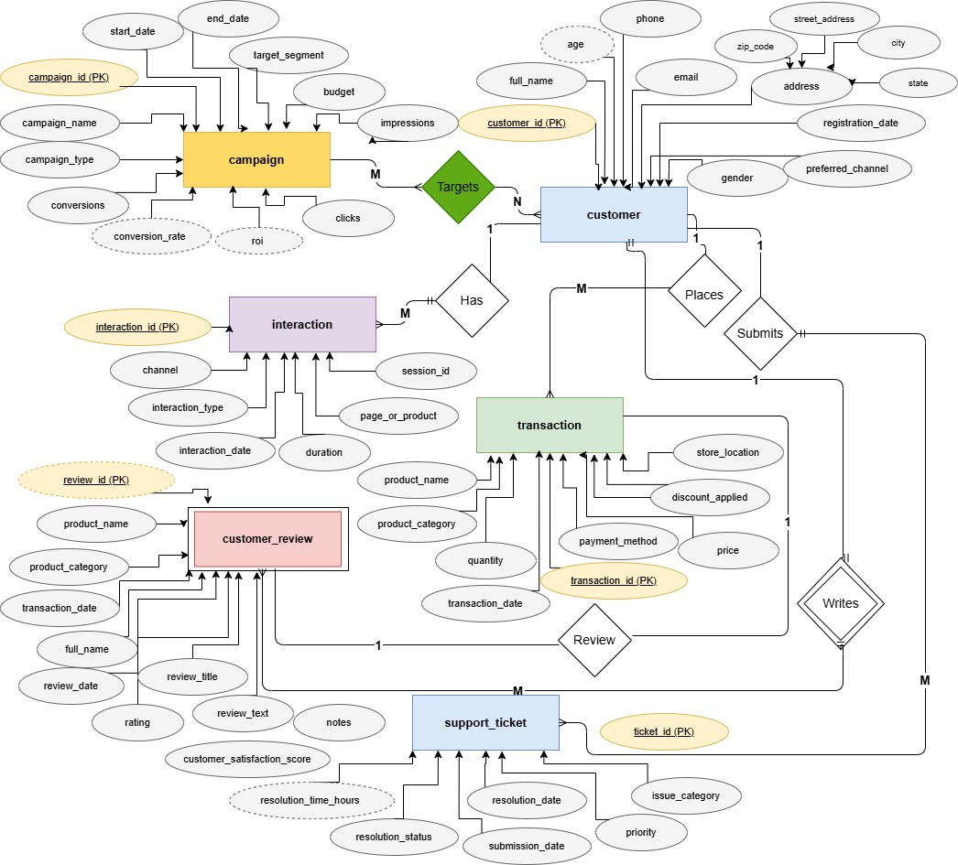

View ER Diagram

Task 2: Preparation of Data Sources

Data Source Overview
To meet the requirement of using at least two different data sources, I organized the dataset using three formats: CSV files, Excel files, and a SQL Server database. This was done to reflect a real- world situation where data comes from different systems and formats.
The table below shows each data source, its format, what kind of data it contains, and the staging table it is connected to.

Source File | Format | Content | Destination Table
customers.csv | CSV | Customer demographics C registration info | stg_Customers
customer_reviews_complete.csv | CSV | Product reviews with ratings and comments | stg_CustomerReviews
support_tickets.csv | CSV | Support issue tracking and resolution | stg_SupportTickets
campaigns.xlsx | Excel | Marketing campaign details and ROI data | stg_Campaigns
interactions.xlsx | Excel | Customer digital channel interactions | stg_Interactions
RetailSourceDB.dbo.src_Transactions | SQL Server (OLE DB) | Purchase transactions from source DB | stg_Transactions

Source Type Details

CSV / Flat File Sources
Used three datasets in CSV format and loaded them using the SSIS Flat File Source component. These files were customers.csv(customer details),customer_reviews_complete.csv(customer reviews), and support_tickets.csv (support and issue data).CSV files are simple text files where data is separated by commas and usually include a header row.

Excel Sources
Used two datasets in Excel format (.xlsx). campaigns.xlsx (marketing campaign data) and interactions.xlsx (customer interction data). I loaded these using the SSIS Excel Source component, which requires setting up an Excel connection manager.

SQL Server OLE DB Source
Stored the transaction data in SQL Server database called RetailSourceDB,inside the table
dbo.src_Transactions.I connected this to SSIS using an OLE DB connection manager and loaded the data using the OLE DB Source component.

Data Enrichment and Hierarchy Planning
I identified some useful hierarchies in the data for analysis. For example, date fields can be broken down into Year > Quarter > Month > Day.Also Product data has categories, so I created a Category
> Product hierarchy. Store data can also be grouped as Physical vs Online. These hierarchies help in better analysis and reporting.

Task 3: Solution Architecture

Architecture Diagram
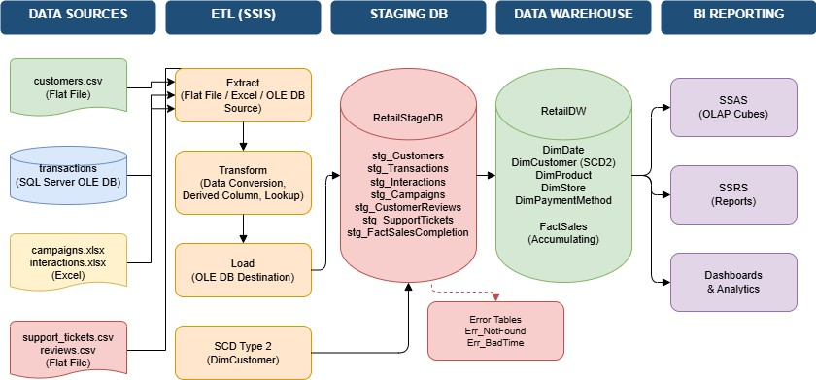
The high-level DW and BI solution architecture follows a classic Kimball-style pipeline, consisting of five layers. Data Sources, ETL (SSIS),Staging Database,Data Warehouse, and BI Reporting. Each layer serves a distinct purpose and is connected in sequence. (view architecture diagram)

Component Descriptions

Data Sources Layer
This is the origin layer where raw data is stored. In my case It include three source types. Flat File sources for customers, reviews, and support tickets, Excel sources for campaigns and interactions, and a SQL Server OLE DB source for transaction data. Data in this layer is in its original unprocessed form.

3.2.2 ETL Layer (SSIS)
SSIS is the middleware engine that connects the data sources to the staging and
warehouse databases. SSIS extracting data from each source, applying transformation logic such as data type conversion, null handling, and derivation of new columns, and loading the results to the destination tables.

Staging Database
The staging layer acts as a temporary holding area for raw extracted data. The database RetailStageDB contains one staging table per source dataset stg_Customers,
stg_Transactions, stg_Interactions, stg_Campaigns, stg_CustomerReviews, and
stg_SupportTickets. Additional table stg_FactSalesCompletion was created to support the accumulating fact update process. The staging layer decouples source extraction from warehouse loading, enabling cleaner error handling and re-processing.

Data Warehouse
Main The data warehouse RetailDW is the analytical store. It is organized as a Star Schema with one central fact table (FactSales) connected to five dimension tables(DimDate, DimCustomer, DimProduct, DimStore, DimPaymentMethod). DimCustomer implements Slowly Changing Dimension (SCD) Type 2 logic to preserve historical customer records.

BI Reporting Layer

The BI reporting layer consumes data from the data warehouse and presents it to business users through dashboards and reports. This layer is intended to be served by SSAS (for
cubes) and SSRS (for tabular reports), which will be developed in Assignment Task 4: Data Warehouse Design and Development

Dimensional Model Overview
The data warehouse in this project uses a Star Schema design. In this design, there is one main table called the fact table in the center,and it is connected to several dimension tables around it The dimension tables give extra details about the data in the fact table.
The schema has one fact table (FactSales) and five dimension tables.The DimCustomer table is designed to keep history.This means when customer details change, the old data is saved instead of being replaced(SCD Type 2)

Dimension and Fact Table Summary

Table Name | Type | Key Columns | Description
DimDate | Dimension | DateKey (PK) | Calendar hierarchy: Year, Quarter, Month, Day, Weekend flag
DimCustomer | SCD Type 2 Dimension | CustomerKey (PK), customer_id | Customer profiles with EffectiveFrom/To and IsCurrent for history
DimProduct | Dimension | ProductKey (PK) | Unique product names and categories
DimStore | Dimension | StoreKey (PK) | Store locations and sales channels (online/physical)
DimPaymentMethod | Dimension | PaymentMethodKey (PK) | Payment method types (Credit Card, PayPal, Cash, etc.)
FactSales | Fact Table (Accumulating) | SalesFactKey (PK), transaction_id (UQ) | Transactional metrics: qty, price, discount, process times

- DimDate
DimDate is a standard calendar dimension populated independently,Not from the source data.It stores one row per calendar date and supports hierarchical drill-down in SSAS cubes and SSRS reports.The DateKey column is an integer an in the format YYYYMMDD and serve as the primary key.The dimension contains CalendarYear, CalendarQuarter, MonthNumber, MonthName, DayOfMonth, DayName, WeekOfYear, and IsWeekend, providing full time-based analysis at any level of granularity.

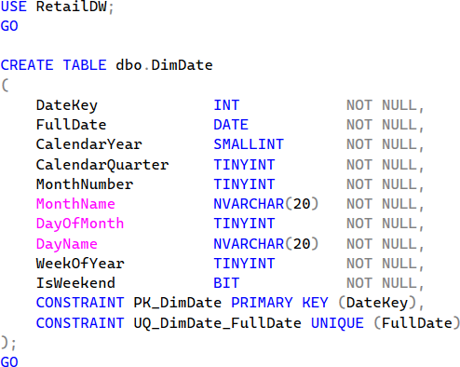
- DimCustomer (SCD Type 2)
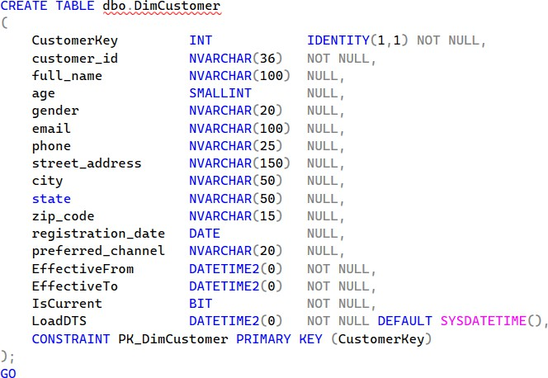
DimCustomer stores customer details.If customer details change (like address or email), a new row is added instead of changing old data. This keep history .Fields like EffectiveFrom, EffectiveTo, and IsCurrent show which record is active.CustomerKey is an auto number (main ID).customer_id is the orijinal ID from source.Details like age, gender,city, and chanel are saved with history.

- DimProduct
DimProduct stores unique combinations of product_name and product_category.it ensure that no duplicate product entries are loaded. The product_category attribute introduces a two-level
product hierarchy (Category > Product Name)

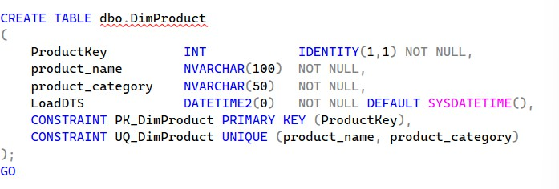
- DimStore
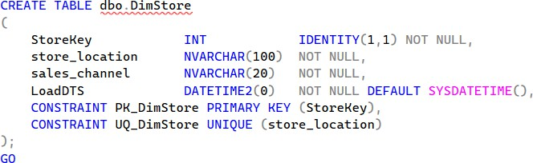
DimStore stores store location information.A derived column transform in SSIS is used to compute the sales_channel attribute, categorizing each location as either 'Online' or 'Physical' based on the store_location value.

- DimPaymentMethod
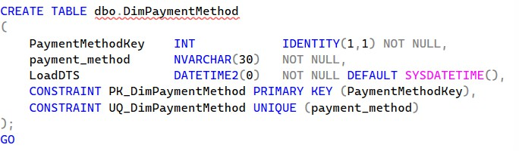
DimPaymentMethod stores the distinct payment methods available in the transaction data,such as Credit Card, PayPal,Cash. Like DimProduct and DimStore. it use Lookup transformation in SSIS to load only new values.

- FactSales
FactSales is the central accumulating fact table.Each row represents one unique sales
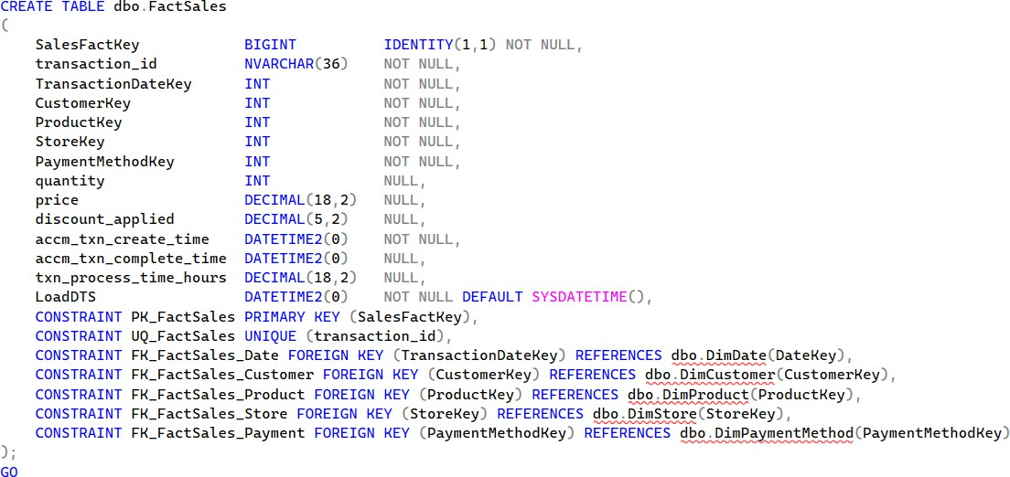
transaction. The table holds surrogate foreign keys to all five dimension tables,with the measure quantity, price, and discount_applied. Three additional columns support the accumulating fact pattern.sucj as accm_txn_create_time, accm_txn_complete_time, and txn_process_time_hours.

Data Warehouse Schema Diagram (Star Schema)
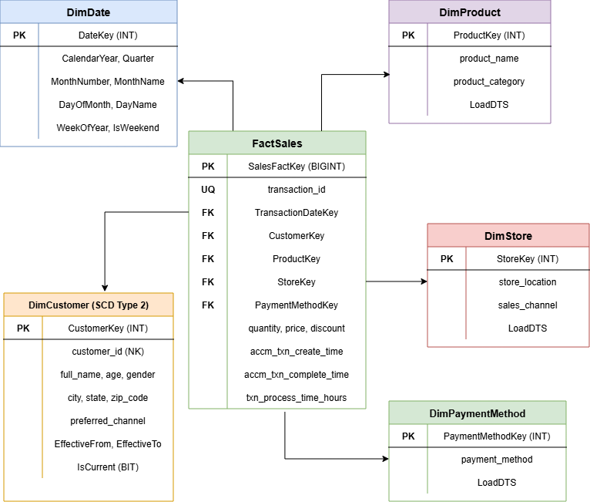
This diagram shows all five dimension tables connected to the central FactSales table through foreign key relationships. The diagram includes all primary keys, foreign keys, and key measure columns.

(View star diagram)

Task 5: ETL Development

ETL Design Overview
The ETL process was built entirely using SQL Server Integration Services (SSIS). To ensure data consistency referential integrity, the ETL was designed and executed in a specific order.
dimensions must be loaded before the fact table, because the fact table relies on surrogate keys from the dimension tables. The staging layer was loaded first, followed by dimension tables,and finally the fact table.

Staging Layer ETL
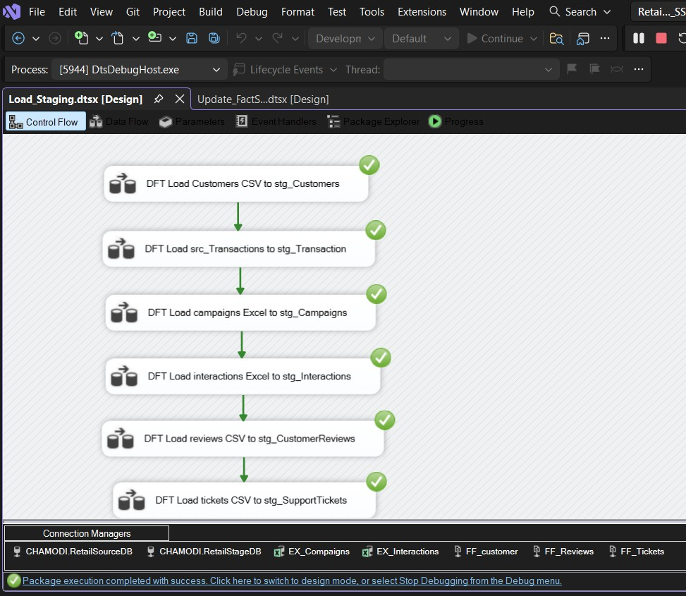
The first SSIS package loaded all source data into the RetailStageDB staging tables. A separate Data Flow Task was created for each source.

The following SSIS components were used in the staging package:
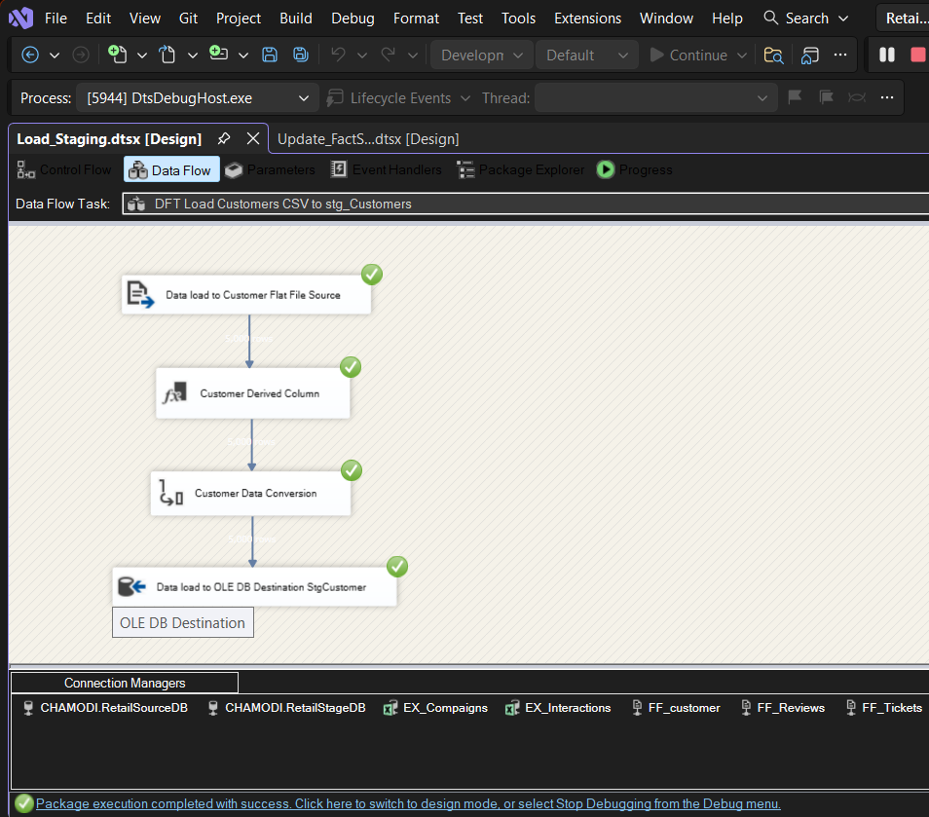
- Extract data from customers.csv

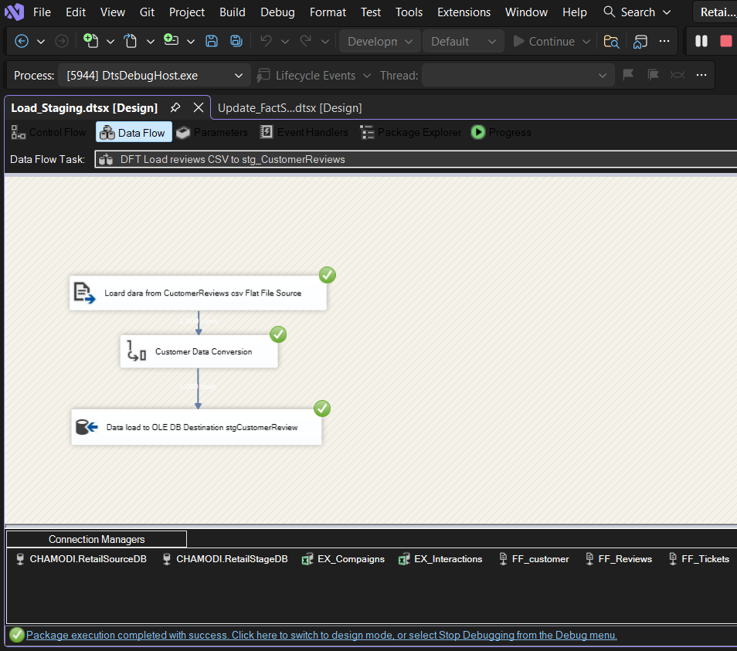
- Extract data from customer_reviews_complete.csv

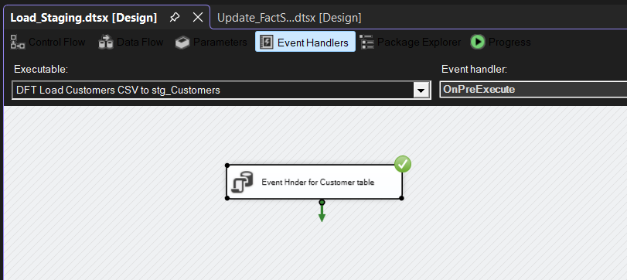
Even Handler for cutomer(For Truncate table)

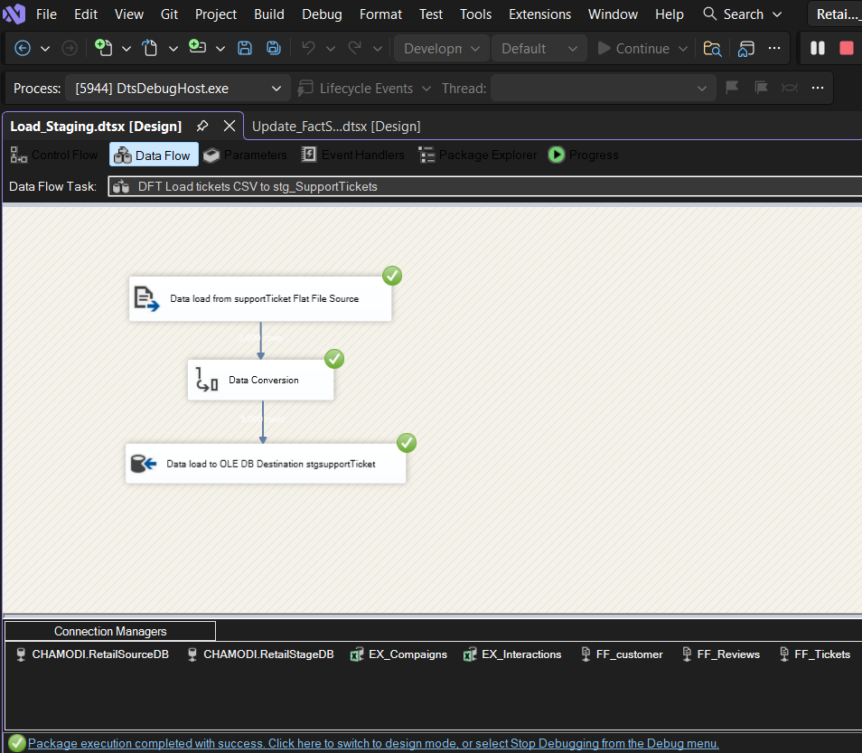
- Extract data from support_tickets.csv.

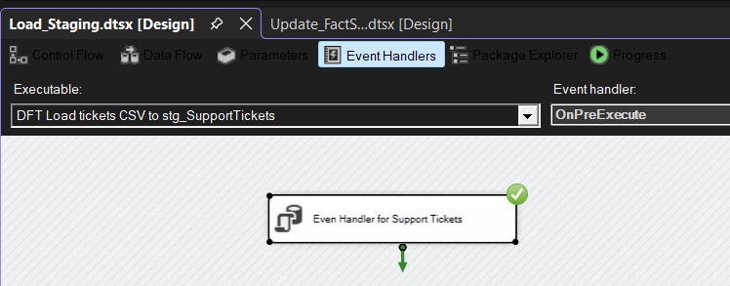
Even Handler for ticket (For Truncate table)

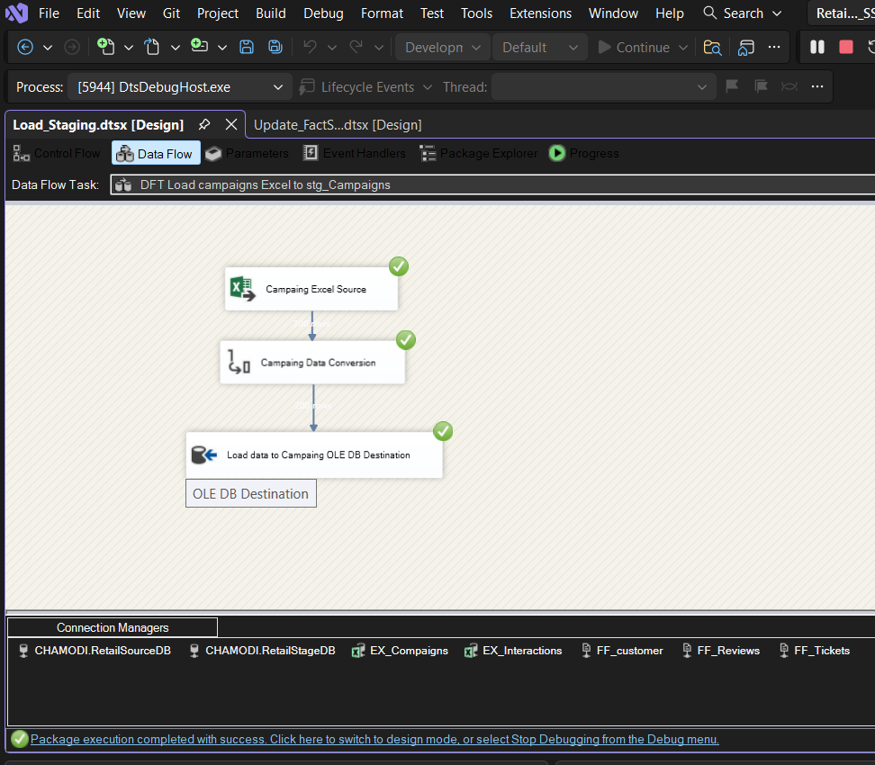
- Extract data from campaigns.xlsx

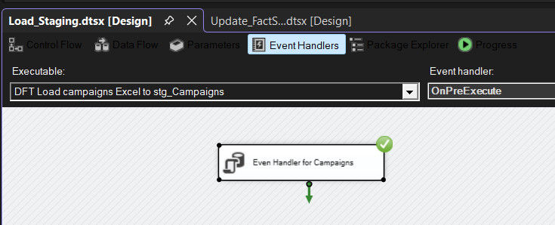
Even Handler for Campaing (For Truncate table)

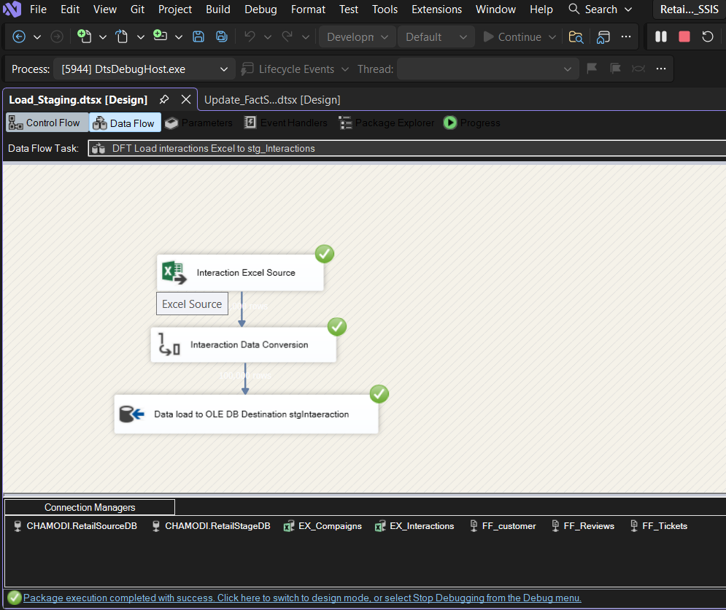
- Extract data from interactions.xlsx.

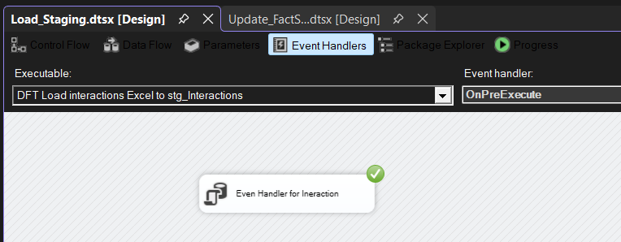
Even Handler for Interaction (For Truncate table)

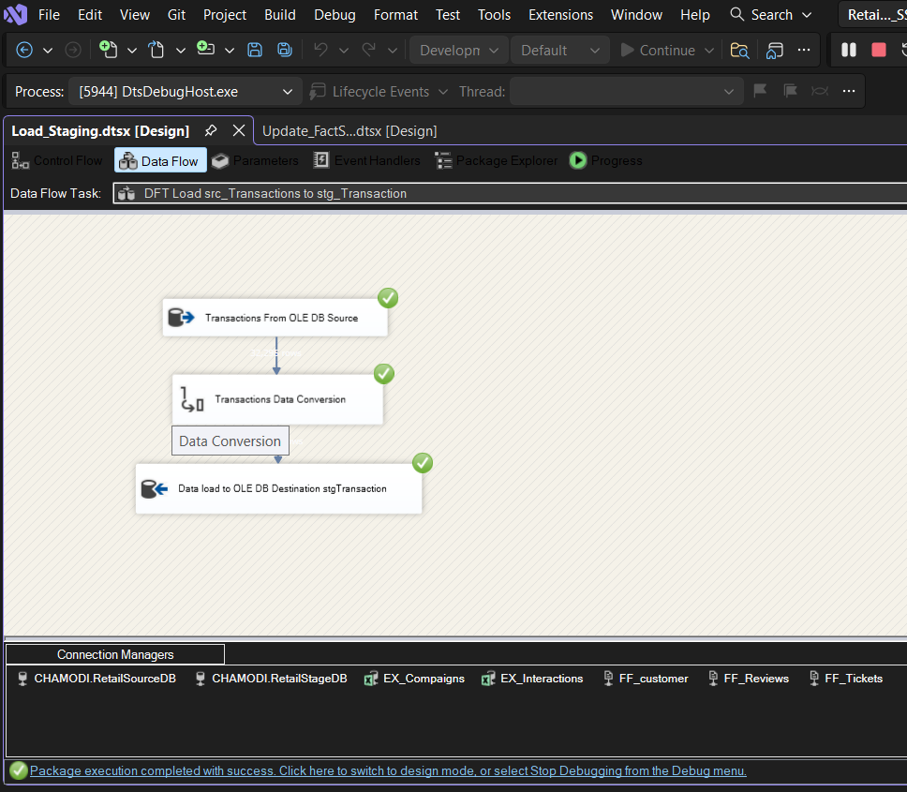
- Extract transaction data from RetailSourceDB.dbo.src_Transactions

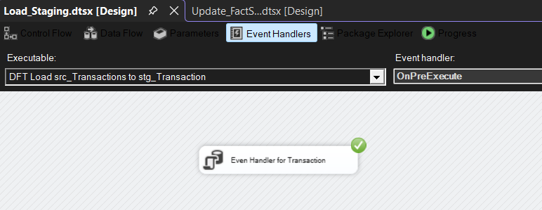
Even Handler for transaction(For Truncate table)

Dimension ETL
Dimension ETL loads and prepares descriptive data (like customers, products, stores) into dimension tables.First, data is extracted from source files, then cleaned and transformed (remove duplicates, handle missing values, format data).After that, surrogate keys are
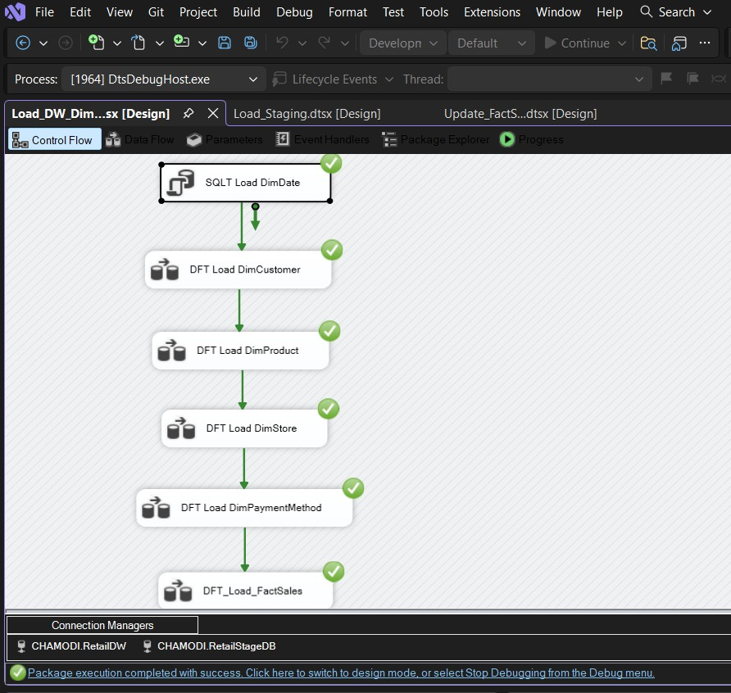
generated for each record. Finally, the cleaned data is loaded into dimension tables so they can be useto connects with the fact table for analysis

- DimDate Load
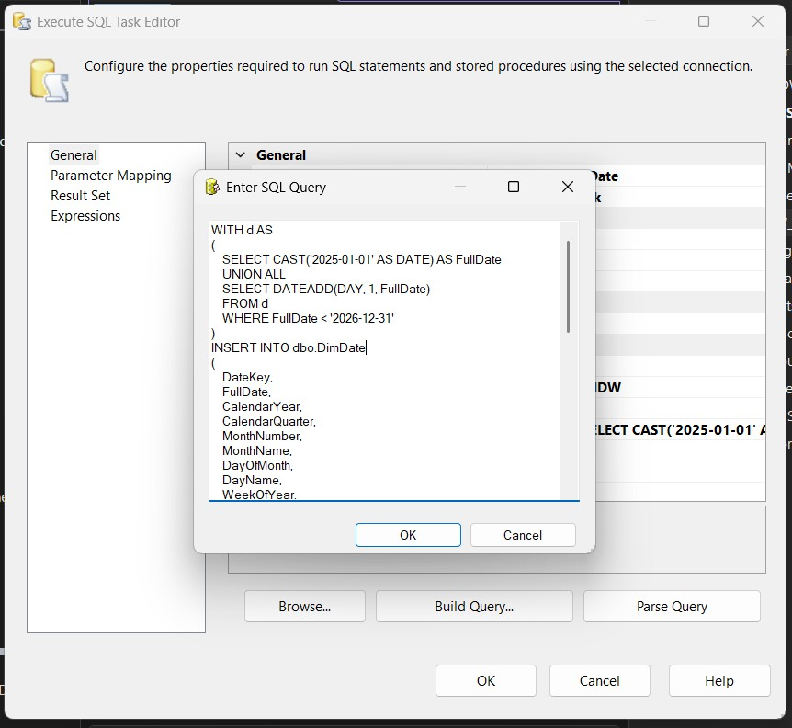
The DimDate table is used to store all dates in the data warehouse in a structured way. Instead of keeping raw dates in fact tables, we use this table to make analysi easier.Each row in DimDate represent one day and contain useful details such as year, month, quarter, day name, and whether it is a weekend.

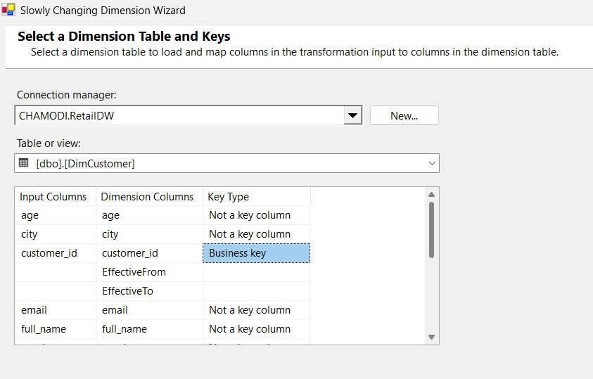
- DimCustomer Load with SCD Type 2
Loading DimCustomer required SCD Type 2 handlingIf customer data changes, a new row is added.Old row is marked as not current. New customers are added as new rows.
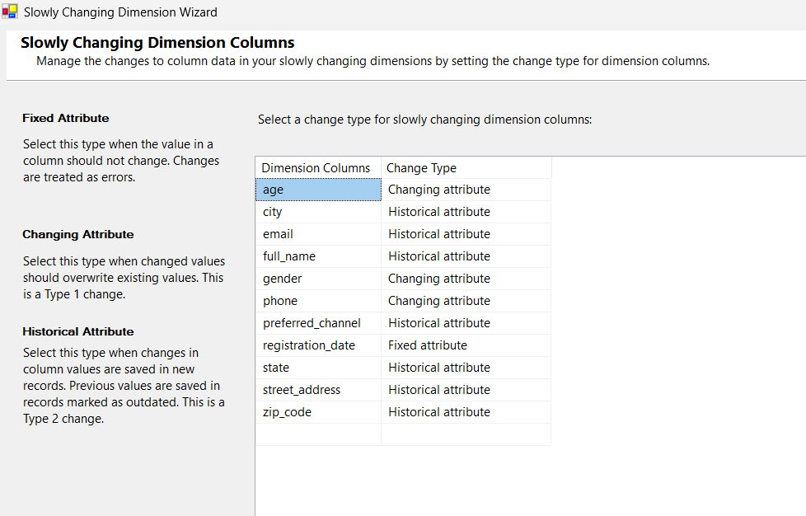
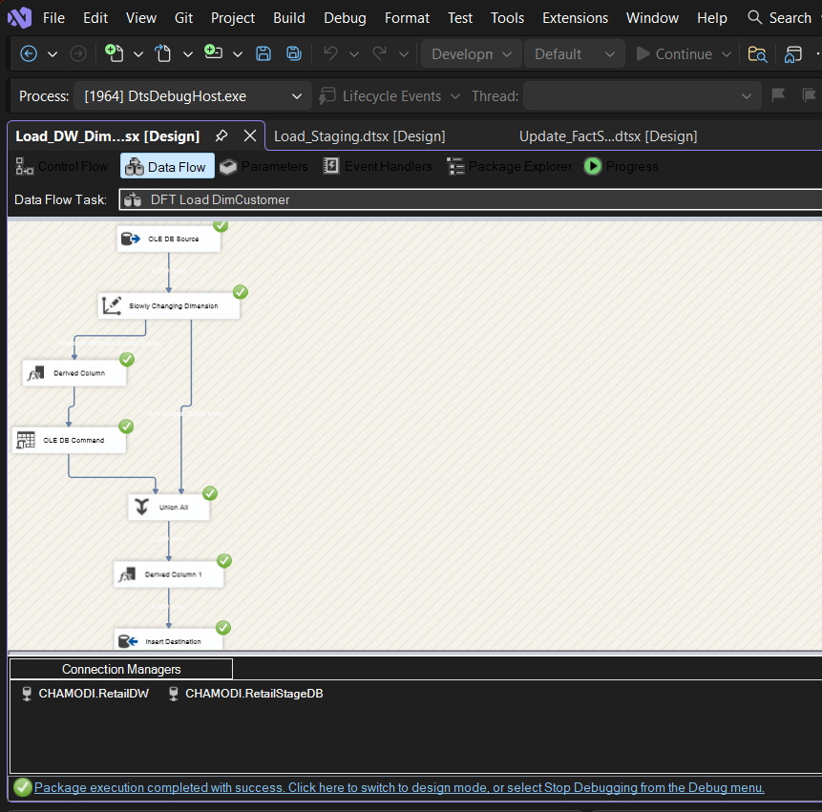

- DimProduct Load
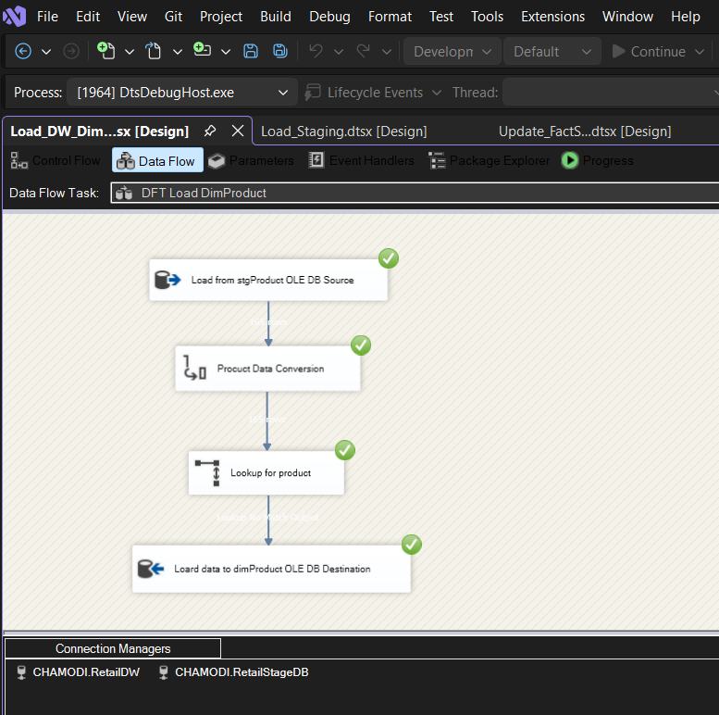
DimProduct, DimStore,DimPaymentMethod dimensions were loaded using a similar pattern.SSIS check if data already exists.

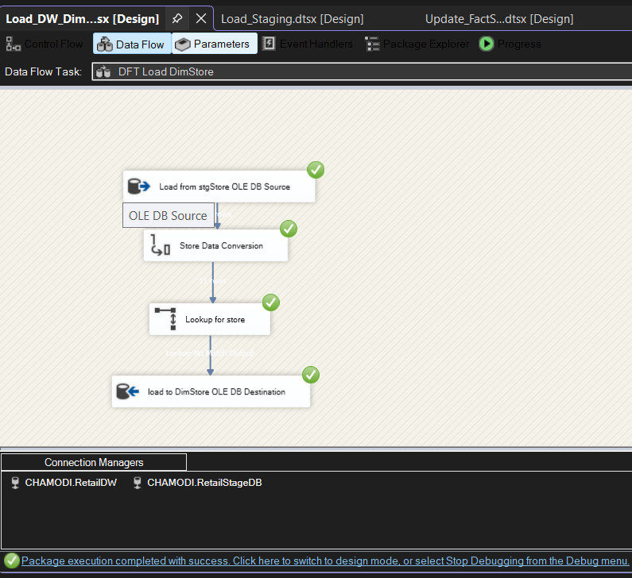
- DimStore Load

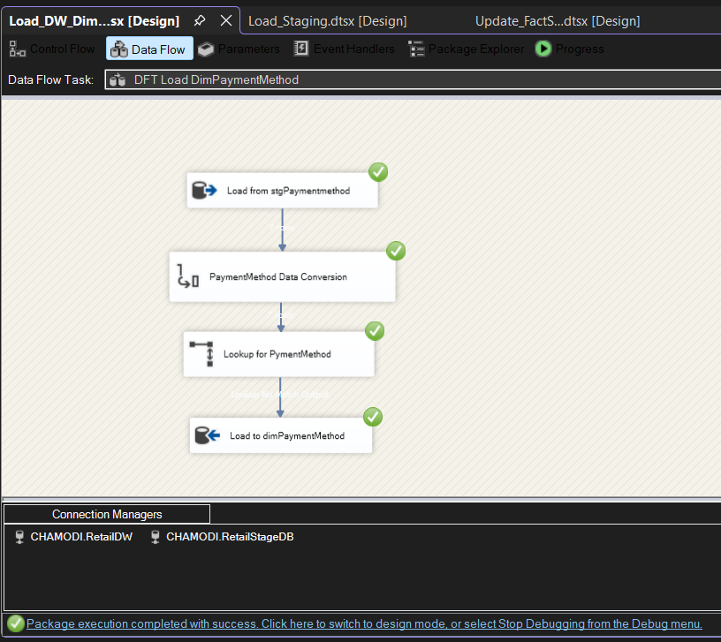
- DimPaymentMethod Load

- Fact Table ETL (FactSales)
The FactSales SSIS package was run last,after all dimensions were fully load. The Data Flow Task performe the following steps in order:
- Read cleaned transaction data from stg_Transactions.
- Use Lookup Transformations to resolve surrogate keys- TransactionDateKey from DimDate, CustomerKey from DimCustomer (IsCurrent = 1), ProductKey from DimProduct, StoreKey from DimStore, PaymentMethodKey from DimPaymentMethod
- Use a Derived Column transformation to set accm_txn_create_time = GETDATE() (current system timestamp)
- Leave accm_txn_complete_time and txn_process_time_hours as NULL for initial load.
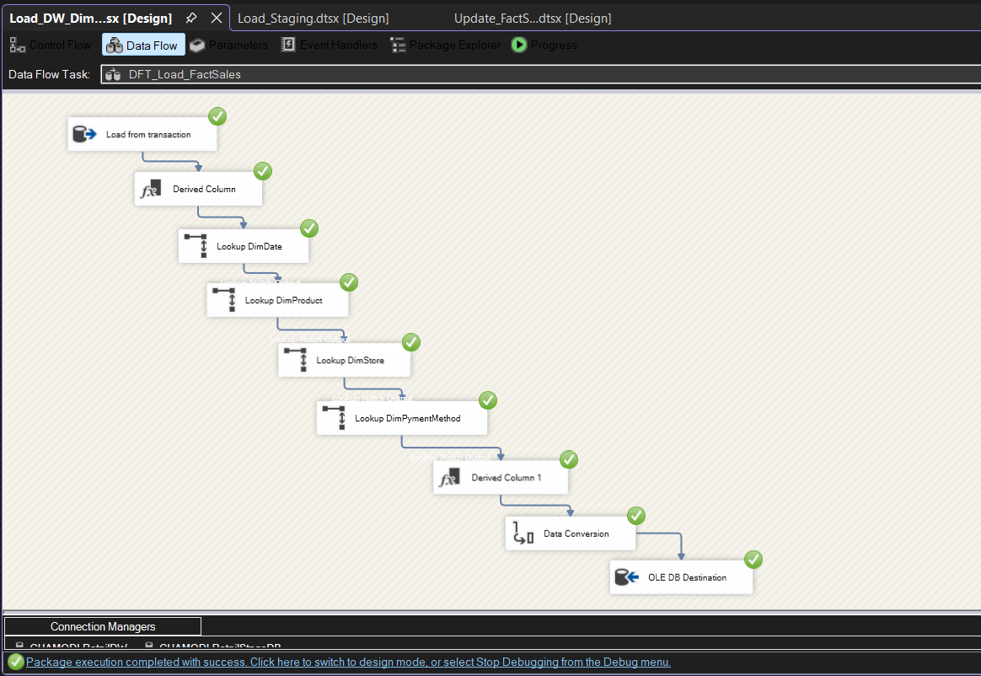
- Load resolved rows into FactSales using OLE DB Destination

Task 6: ETL Development – Accumulating Fact Tables

Overview of Accumulating Fact Tables
This table tracks a process from start to end.It store start time and end time, and updates when changing happen.In this project, FactSales tracks sales.It records when a sale starts, when it
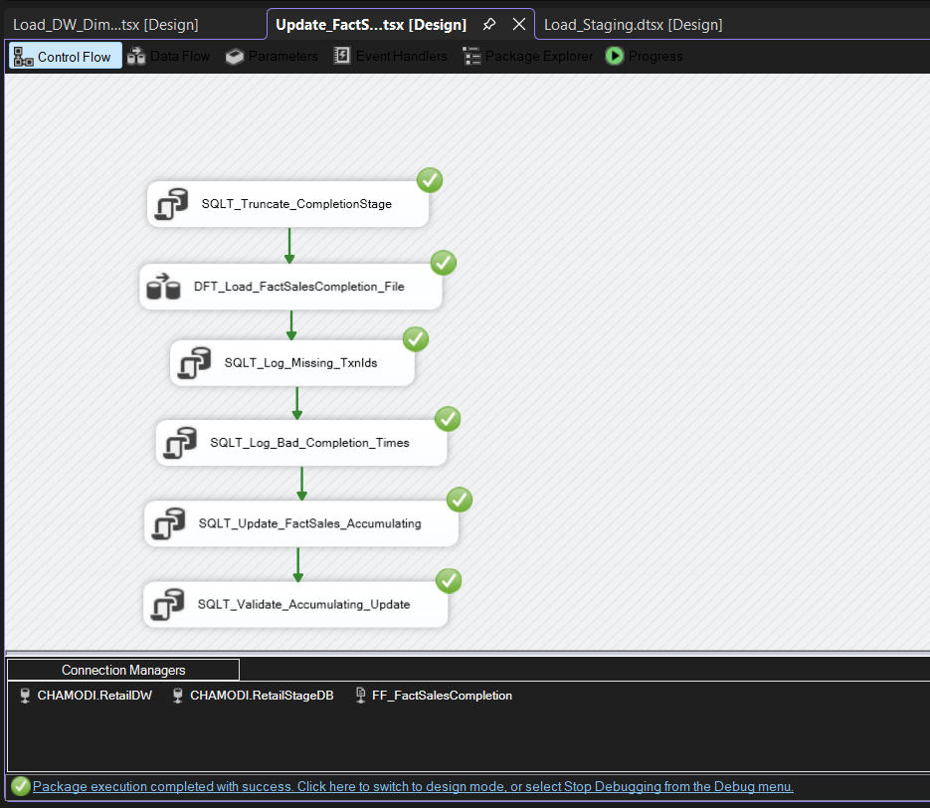
finish, and how long it take.

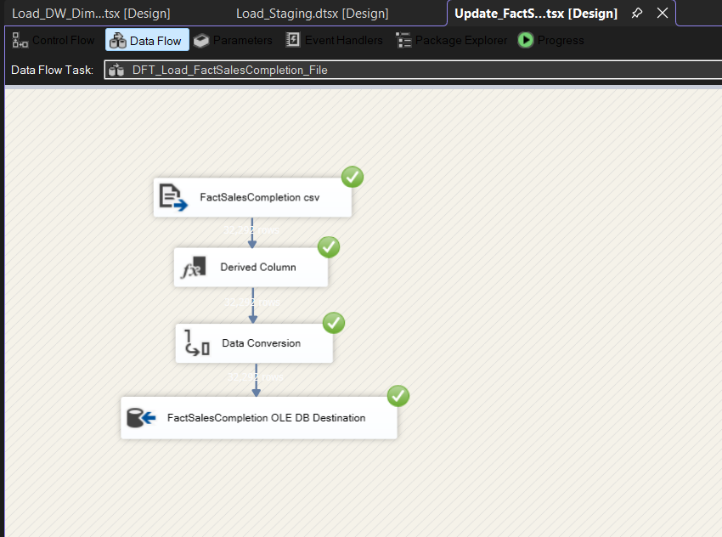
Fact Table Extension
The FactSales table was extended with three columns to support the accumulating fact pattern:
    - accm_txn_create_time (DATETIME2)
Populated at the time of initial fact load using SYSDATETIME().Represent when the transaction record entered the warehouse.
•accm_txn_complete_time (DATETIME2, nullable)
Initially NULL. Updated by a separate SSIS package when the transaction completion data arrive
•txn_process_time_hours (DECIMAL(18,2), nullable)
Calculated as the difference in hours between accm_txn_complete_time and
accm_txn_create_time. Set to NULL initially and computed during the update process.

Completion Dataset
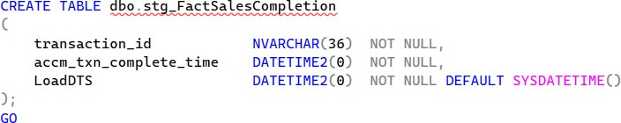
A separate dataset was prepared with the following structure to simulate transaction completion events arriving from an external source

Error Tables
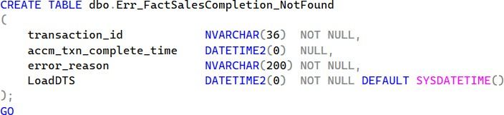
Two error tables were created in RetailDW to capture and log problematic records during the accumulating fact update processs

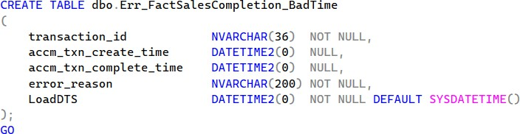
Error table for invalid timestamps (complete time before create time)

The Err_FactSalesCompletion_NotFound table captures records where no matching
transaction_id was found in FactSales. The Err_FactSalesCompletion_BadTime table captures records where the completion time was earlier than or equal to the creation time, which would produce an invalid process duration.

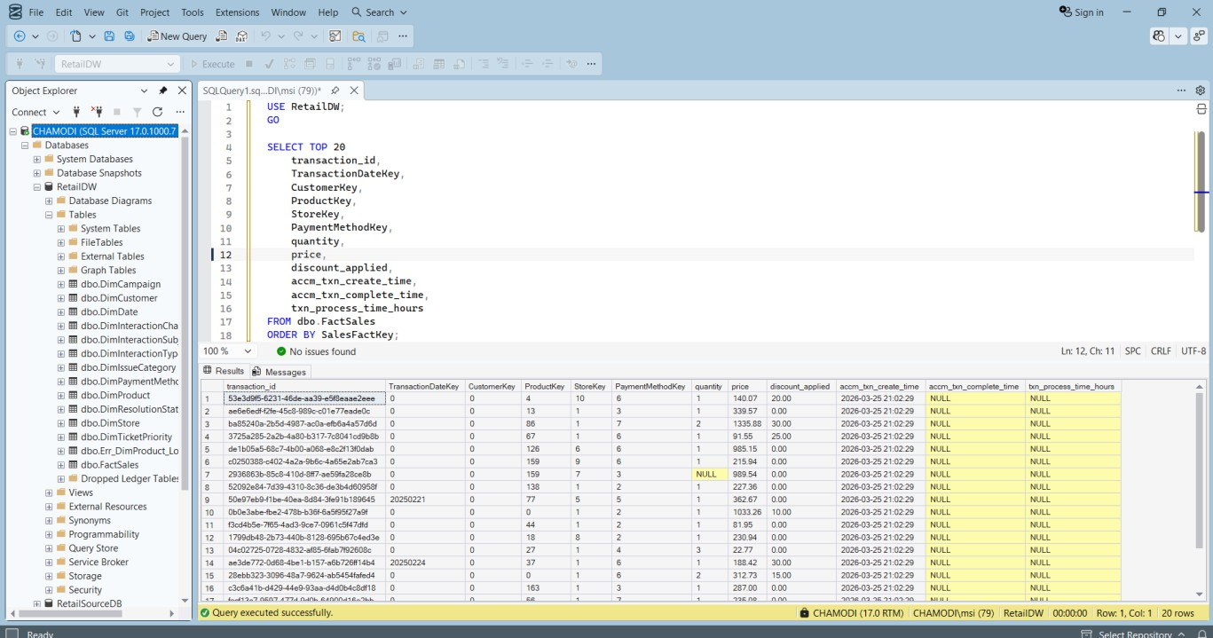
- facSales table before task 6

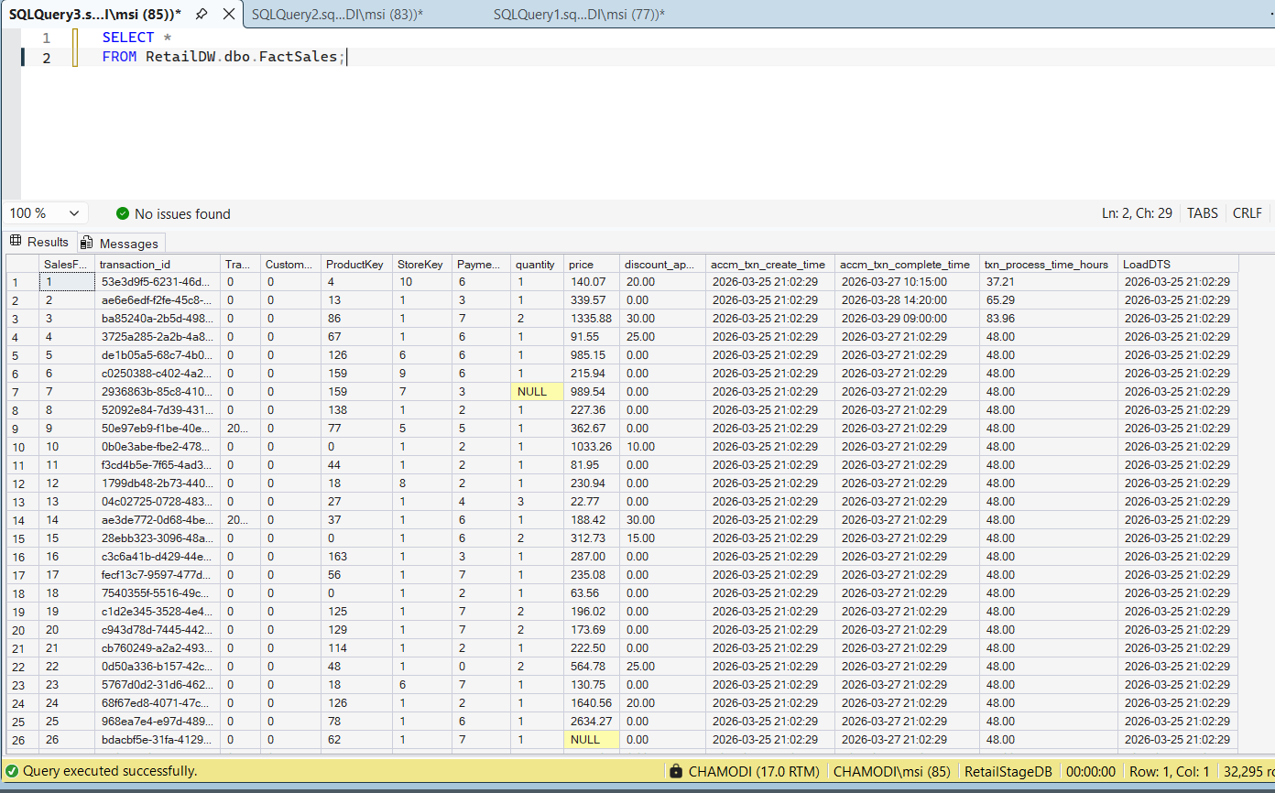
- facSales table After task 6

